**Basic concepts in python programming**

def test_var_args(f_arg,*argv,**kwargs):

print("first normal arg:",f_arg)

if argv is not None:

for arg in argv:

print("another arg through *argv:",arg)

if kwargs is not None:

for(key,value) in kwargs.items():

print(key,value)

test_var_args('Training')

test_var_args('Learning','Python','Third','Day')

test_var_args('Programming','Filehandling','Python', Name="Praveen", Profession="Trainer")

test_var_args('Programming', Name="Praveen", Profession="Trainer")

**OUTPUT**

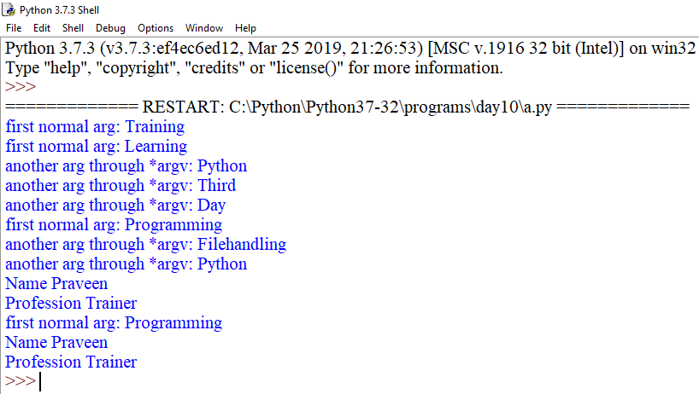

total=100

def add(arg1,arg2):

global total

total=arg1+arg2

print("Inside the function local total:",total)

return total

a=add(10,20)

print("Outside the function global total :",total)

**OUTPUT**

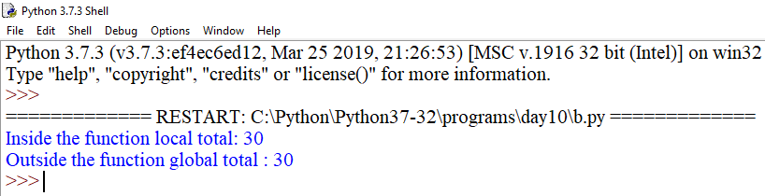

x=5;y=7

def changeme(mylist):

p=89

global x,y

x=y+2

mylist=[1,2,3,4]

print("Values inside the function:",mylist)

print("Local variables are:",locals())

print("Global variables are:",globals())

return

mylist_var=[10,20,30,40]

changeme(mylist_var)

print("Values outside the function:",mylist_var)

**OUTPUT**

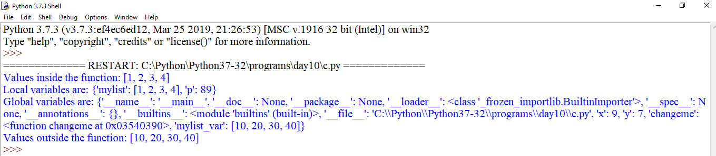

def factorial(n):

if n==0:

return 1

else:

return n*factorial(n-1)

print("factorial of 3:",factorial(3))

print("factorial of a large no:",factorial(100))

**OUTPUT**

